Database Indexing

Reference : <https://www.youtube.com/watch?v=0X9bbtwTnuE&index=1&list=PLUWdEQb_2yqVXnx-P1881VVtec8moW1sk>

**What are indexes ?**

Indexes are database objects which can be created on table or table clusters , speedup data retrieval in certain cases.

When we store data in table it will be stored in memory as file and it can have its own flie structure.

The entire table data is stored and distributed in different memory blocks. There are two indexing

B-tree (Balanced tree)

B-Map (Bit map)

**How data are stored ?**

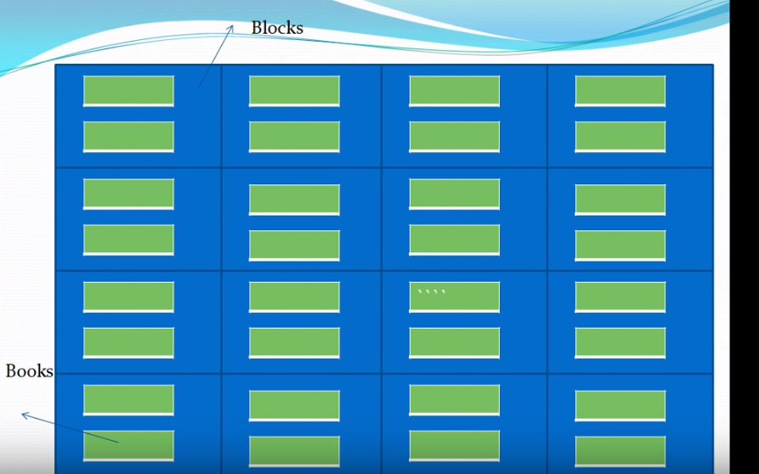

Data is divided and stored in blocks, every block has an address and the green color boxes are the physical datas which are stored in the block.

**How to check in sql ?**

Explain plan for select * from [\**tablename*\*] where id =10

Select * from table(dbms_xplan.display)

-----------------------------------------------------------------------------

| Id | Operation | Name | Rows | Bytes | Cost (%CPU)| Time |

-----------------------------------------------------------------------------

| 0 | SELECT STATEMENT | | 1 | 37 | 2 (0)| 00:00:01 |

| 1 | TABLE ACCESS FULL| STUDENT | 1 | 37 | 2 (0)| 00:00:01 |

-----------------------------------------------------------------------------

By default TABLE ACCESS FULL is applied , means it will scan each and every block

If I create an unique index

**create unique index idx_student_id on student(studentid)**

the same query will give me

----------------------------------------------------------------------------------------------

| Id | Operation | Name | Rows | Bytes | Cost (%CPU)| Time |

----------------------------------------------------------------------------------------------

| 0 | SELECT STATEMENT | | 1 | 37 | 1 (0) | 00:00:01 |

| 1 | TABLE ACCESS BY INDEX ROWID| STUDENT | 1 | 37 | 1 (0) | 00:00:01 |

|* 2 | INDEX UNIQUE SCAN | IDX_STUDENT_ID | 1 | | 0 (0)| 00:00:01 |

----------------------------------------------------------------------------------------------

Now the plan changed to INDEX UNIQUE SCAN

**How indexes are stored ?**

ID RowId

1. 1AA67549BBCC34
2. 1AA67549BBCC35
3. 2AB67549BBCC34

The indexes are stored like mentioned figure . Rowids are nothing but address of each and every rows. and id are the values of indexes. As above mentioned index is an unique index so each index can contain one unique row, if we use non unique index then each index can contain multiple rowids. So when we search with an id it will not scan the entire table it will just pick the id say 2, find the address of the block search the row in that block. We can say each block can contain multiple rowids.

If we create a unique constrain in backend dbms by default create a unique index .

Select * from user_segments

Segment_name partition_name segment_type bytes Blocks

SYS_C007364 null INDEX 65536 8

So the inex is one kind of segment in dbms which contains a physical memory in system and structured with 8 blocks. table is also an unique index which has a physical memory in databse system.

**Why we can’t create indexes for every field of the table as increases retrieval data performance ?**

Indexes will hamper insert, update , delete performance. Because after creating index we need to insert or update not only table row but also the indexes. It can reduce the crud operation performance. Try to keep index number per table as low as possible.

To get rid of this problem we can make the indexes invisible at crud operation time and for retrieval time again make it visible. DBMS won’t remove or drop the index but do not use the index while storing data.

Alter index idx_student_id invisible

Alter index idx_student_id visible

**How to unusable and visible index ?**

If we make an index unusable dbms will drop the index from the system to make it usable once again we need to rebuild it once again

Alter index idx_student_id UNUSABLE

Alter index idx_student_id REBUILD

But for invisible index dbms will not remove the index, its just that it will not use the index at the time of retrieval.

**Index scan methods**

* Index unique scan
* Index range scan
* Full index scan
* Fast full index scan
* Index skip scan

**In B-tree data structure how index methods work?**

According to the figure root and branch block stores only the address of the other block. Leaf blocks

store the physical indexes. So to retrieve the index we need to traveres till the leaf node of the balanced tree

Root 🡪 branch block 🡪 Traverse leaf block 🡪 table access by index row id

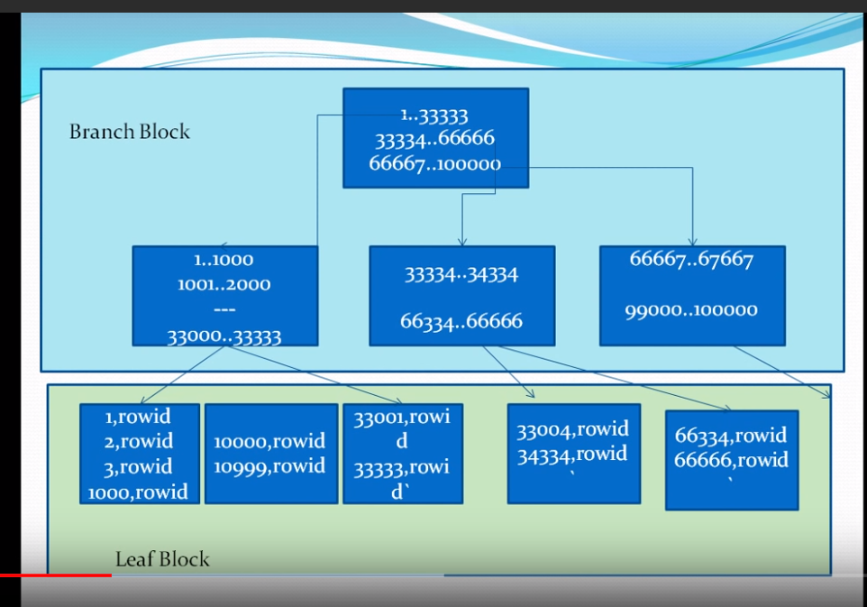

**Index plan for foreign keys ?**

A referential integrity constraint exists on the indexed column or columns. The index is a means to avoid a full table lock that would otherwise be required if you update the parent table primary key. If a parent table primary key is updated or deleted it will lock the entire child table which has foreign key relationship.

As a remedy create indexes for foreign key columns. If a table contains one or more foreign key columns that reference other tables, you need to index those columns. Foreign key columns are usually non-unique because they're on the "many" side of the one-to-many (1:M) relationship. Therefore, you expect to see duplicate values in the foreign key column every time one row in the master table (on the "one" side) is related to two or more rows in the detail table (on the "many" side). You need to create a unique index on a foreign key column only if you're enforcing a mandatory one-to-one (1:1) relationship between two tables. In a 1:1 relationship, the values in the foreign key column are a unique set that corresponds to the primary key values in the master table. When the foreign key column in a table is indexed, SQL Server can scan the indexes for the rows it needs instead of scanning both tables.

**Composite index**

Index can be made on more than one columns in a table. Suppose if we create a composite key on a table DBMS will create a composite index for me. For composite index the order is very importatnt.

Example if we create a primary key constrain(field1, field2, field3)

And query select * from tablename where field2 = ‘ nmnmn’

In this case DBMS is not going to use the index, as field2 is mentioned as a second in order.

If we modify the query select * from tablename where field2 = ‘ nmnmn’ and field1 = ‘kjjkjk’

This time the index will be used.

**Can we create multiple indexes on same column or set of columns ?**Starting with [Oracle 12c](http://www.doblerconsulting.com/tag/oracle-12c/), multiple [indexes](http://www.doblerconsulting.com/tag/indexes/) on same column or same set of columns can be created, as long as only one index is visible, and the [indexes](http://www.doblerconsulting.com/tag/indexes/) are physically different. It is not possible to create two bitmap [indexes](http://www.doblerconsulting.com/tag/indexes/) on the same column or set of columns.

Create the first index on start_dt column. By default, [Oracle](http://www.doblerconsulting.com/tag/oracle/) creates B-tree index.

SQL>  create index idx1_ind_test1 on ind_test1(start_dt);

Index created.

Now, create a second invisible index on the same column

SQL> create index idx2_ind_test1 on ind_test1(start_dt) invisible;

create index idx2_ind_test1 on ind_test1(start_dt) invisible

*

ERROR at line 1:

ORA-01408: such column list already indexed

Index failed because these 2 are the same type of indexes.

You can create a bitmap index on the same column.

SQL>  create bitmap index  idx2_ind_test1 on ind_test1(start_dt) invisible;

Index created.

This feature is useful when you want to test the performance of different indexes without dropping the existing one. If you already have a b-tree index on a set of columns and you want to test whether creating bitmap index on the same set of columns will improve performance, you can make the existing one invisible and create a new visible one and perform the test.

But we can create combination of columns in B-tree index, like

Index1 = combination of field1, field2

Index2 = combination of field3, field2

Index3 = combination of field2, field1

**When to use which index scan methods ?**

<https://gerardnico.com/db/oracle/index_scans>

**How the clustering factor can affect cost.**

Example Effects of Clustering Factor on Cost

Assume the following situation:

* There is a table with 9 rows.
* There is a non-unique index on col1 for table.
* The c1 column currently stores the values A, B, and C.
* The table only has three Oracle blocks.

Case 1: The index clustering factor is low for the rows as they are arranged in the following diagram.

Block 1 Block 2 Block 3

------- ------- --------

A A A B B B C C C

This is because the rows that have the same indexed column values for c1 are located within the same physical blocks in the table. The cost of using a range scan to return all of the rows that have the value A is low, because only one block in the table needs to be read.

Case 2: If the same rows in the table are rearranged so that the index values are scattered across the table blocks (rather than collocated), then the index clustering factor is higher.

Block 1 Block 2 Block 3

------- ------- --------

A B C A B C A B C

This is because all three blocks in the table must be read in order to retrieve all rows with the value A in col1

**Index spawning and and splitting**

<https://www.youtube.com/watch?v=zGUze_5yAwg&list=PLUWdEQb_2yqVXnx-P1881VVtec8moW1sk&index=3>

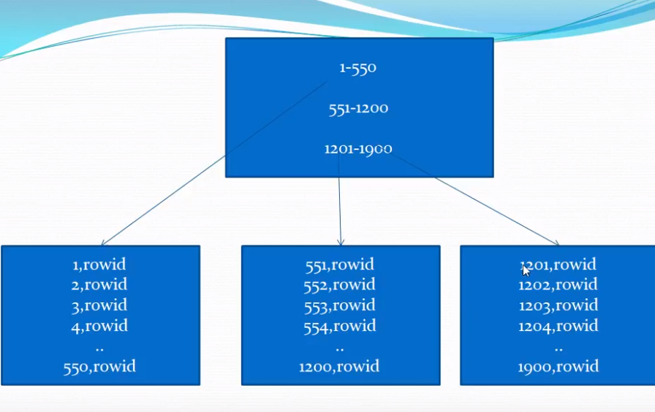

expanding tree height wise is index spawning and by

**How to create bitmap index ?**

If we don’t mention the index type optimizer will always index with B-tree

create bitmap index dpt_emp_idx on employees(gender)

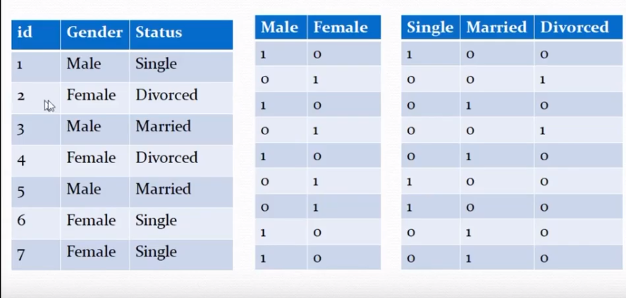

**What is bitmap join index ?**

Bitmap index is for a single table

Bitmap join index can be created on join of two or more tables.

create bitmap index tran_cust_gen_idx on transaction(customer.gender) from transaction t, customer c where c.cust_id = t.cust_id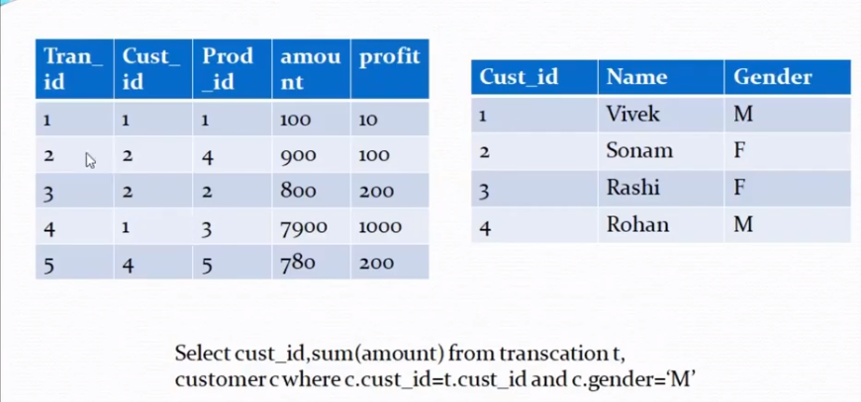

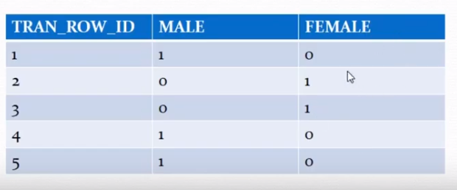

**When to avoid creating bitmap index**

Suppose dept no is the bitmap index. Suppose for dept_no 10, we have a bitmap index

1 0 1 1 0 1 from 6 rows. and for 20 is 010010 for those 6 rows. If an employee is transferred from 10 to 20th dept then the bitmap index needs to be updated, like last row is changed then

10 bitmap is 101100

20 will be 010011

T1 transaction is updating the deptno and T2 is adding an employee in dept 10, then T2 will be blocked unless or until the dept is not updated. So if any column has high cardinality try to avoid creating bitmap index on that column. Means the column on which bitmap index is applied should be updated rarely.